The Unconscious Mind Perpetuates "Us vs. Them" Bias

Noninvasive brain stimulation sheds light on implicit bias.
By: Christopher Bergland, Posted Oct 16, 2018
A new review of noninvasive brain stimulation (NBS) by Harvard researchers offers fresh clues about specific brain regions that may be associated with holding stereotypical “implicit bias” towards members of outside groups beneath the level of conscious awareness. The paper, “Studying Implicit Social Cognition with Noninvasive Brain Stimulation,” was recently published online ahead of print in the journal Trends in Cognitive Sciences.
In a statement, the researchers said: “The tendency to be suspicious of people we perceive as strangers or 'not like us' probably evolved early in our ancestry, when small groups of humans competed against each other for precious resources like food and water.” Their review sheds light on the neurobiology of “us vs. them” stereotypes and could lead to new behavioral interventions designed to minimize the divisiveness of implicit bias.
In 1998, “Project Implicit” was founded by a trio of social psychological scientists that included Tony Greenwald, who is currently a professor of psychology at University of Washington; Mahzarin Banaji of Harvard University's Psychology Department; and Brian Nosek, professor of psychology at the University of Virginia, who is also co-founder and director of the Center for Open Science.
Project Implicit is a non-profit organization that brings together a collaborative network of researchers from around the globe to investigate “implicit social cognition,” which refers to the thoughts and feelings we have towards others that tend to occur on an unconscious level beyond the realm of conscious awareness and cognitive control. The primary goal of this organization is to educate the public about hidden biases and to provide an online “virtual laboratory” for collecting data about implicit social cognition.
One of the primary tools used by the group is called an “Implicit Association Test” (IAT). These tests measure unconscious “not like us” attitudes that people are often unwilling or unable to consciously self-report when filling out a questionnaire due to political correctness and the subliminal nature of these biases, respectively.
Oftentimes, implicit bias occurs so far under the radar of explicit awareness that your conscious mind may not even “know” you unconsciously hold a negative stereotype. As an example, you might firmly believe in your rational, conscious mind that women and men are equally qualified to be airline pilots. Then out-of-the-blue one day, you find yourself on a plane with two female pilots and no men in the cockpit. Suddenly, you have a gut feeling of panic and realize in this split-second of unease that you'd actually feel more comfortable if a man was flying the plane. This type of gender-based implicit bias is typical when women have careers in male-dominated professions.
The latest multidisciplinary review on NBS and implicit social cognition was conducted by lead author Maddalena Marini, formerly a postdoctoral fellow in the Department of Psychology at Harvard University, along with Project Implicit co-founder Banaji and senior author Alvaro Pascual-Leone of the Berenson-Allen Center for Noninvasive Brain Stimulation at Harvard's Beth Israel Deaconess Medical Center (BIDMC).
"Unlike traditional brain imaging techniques, noninvasive brain stimulation can directly impact brain activity and provide powerful evidence that specific brain regions are linked to specific social behaviors—in this case, we applied it to attitudes and stereotypes towards groups that vary in social characteristics, such as race and ethnicity," Pascual-Leone said in a statement. "Modulating the brain activity in these regions can yield insights relevant to our modern, more diverse societies—in which our primitive group allegiances can be in conflict even with one's own standards of equal opportunity, fairness, and justice."
Their review suggests that the anterior temporal lobe may be a central player involved in how the brain creates implicit bias by linking stereotypical attributes to a category of people. This review also found that processing implicit attitudes (e.g., religious beliefs) activates the inferior parietal lobe. Previous research has found this brain area to be involved in theory of mind (e.g., putting yourself in someone else's shoes) and making moral decisions. Notably, the review of NBS and implicit social cognition concludes: "Modulation of the medial prefrontal cortex can change the expression of implicit stereotypes and attitudes by operating on its control and regulation mechanisms."
I have a personal, anecdotal example of implicit bias and "us vs. them" stereotyping. I know from first-hand experience as a gay man and “Ironman” triathlete that onlookers and fellow competitors were often consciously and unconsciously surprised that I wasn’t straight. The prevalence of "sissy boy" stereotypes was especially apparent when I beat a hyper-masculine heterosexual in a grueling "balls-to-the-wall" triathlon. Based on the conclusions by Marini et al., it seems that the anterior temporal lobe might play a subliminal role in the implicit assumption by some people that “gay men are sissies.”
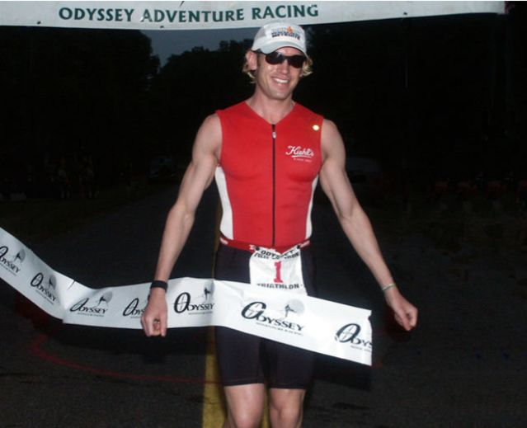In the early 2000s, Christopher Bergland won the longest non-stop triathlon in the world three years in a row (2001-2003) with a record-breaking time of 38 hours and 46 minutes. The “Triple Ironman” consists of a 7.2-mile swim, 336-mile bike and, 78.6-mile run done consecutively without sleep. As a gay triathlete who was sponsored by the skincare company “Kiehl’s,” Bergland embraced the moniker “Ironman Barbie” as a way to consciously address implicit bias and break stereotypes about gender, sexual orientation, and athleticism. Source: Dawn Mann, used with permission
As an openly gay Ironman triathlete, I began competing on the international circuit in the early 1990s, at a time when very few athletes were out of the closet. The look on people’s faces when they realized I was "homosexual," along with random comments I’d overhear from the sidelines, was a constant reminder of the implicit bias surrounding male homosexuality and excelling in sports competition. As a way to consciously address this implicit bias with a wink and a nod, I’d jokingly refer to myself as “Ironman Barbie.” This term may seem politically incorrect, but it served as a tongue-in-cheek way to take ownership of being treated like a second-class citizen in certain situations and to speak about the elephant in the room at award ceremonies.
Observationally, it often seemed to me that somewhere in the back of their minds, men who were part of a heterosexual group of triathletes implicitly and explicitly thought, “He’s not like us.” Luckily, I had no desire to be a part of their clique and thrived on being an underdog and outsider. That said, to my surprise, even people who weren't the least bit homophobic seemed to subconsciously hold an implicit bias that being a “gay Ironman” was an oxymoron.
"Social beliefs reflect associations that are strongly ingrained in our brains, and changing them will likely entail the reconfiguration of their underlying biological processes," Maddalena Marini said in a statement. "No behavioral interventions designed to shift social beliefs so far—such as empathytraining—have produced robust and long-lasting effects. Noninvasive brain stimulation techniques can provide insights that may help meet the urgent need in our society to better understand our intergroup social behavior."
The authors conclude, "NBS methods, such as transcranial magnetic stimulation (TMS) and transcranial direct-current stimulation (tDCS), can interfere with ongoing brain activity in targeted brain areas and distributed networks, and thus offer unique insights into the mechanisms underlying how we perceive, understand, and make decisions about others. NBS represents a promising tool to promote knowledge about the social minds of humans."

