Effect of Time on the Recall of Non-Schematic Objects
IB Candidate Code: hhn496
IB Candidate Codes of Group Members: hhn547, hhn559
11/20/18
Word Count: 2,198

Introduction
Prior knowledge is important in information processing. Schema theory states that all knowledge is organized into units to aid the brain in the comprehension process.
The aim of our experiment is to investigate the effect of time on the recall of non-schematic items. This experiment is relevant since humans rely on schema on a day-to-day basis; the human brain tries to make connections and find relationships in the world so that processing information will be more efficient. Schemas can be thought of as the “foundation” in acquiring new knowledge. For example, schema of a typical high school classroom would be a classroom containing desks, chairs, pencils, etc. Since humans oftentimes use schemas to make assumptions, they can have an impact on our perception and memories.
Our investigation is based on an experiment testing schema theory by Brewer & Treyens (1981). The aim in their experiment was to investigate whether existing schema of an office impacts the recall of objects in the room. Brewer & Treyens’ subjects (30 university students) were placed in an office containing schematic items (desk, typewriter, coffeepot, and calendar) in addition to non-schematic objects (skulls, wine bottles, pliers, and bark). After 35 seconds, the participants were led out of the office and placed in a separate room. Brewer & Treyens asked the participants to write down as many objects as they could remember seeing in the room. The results were that participants were able to recall the schematic items. Due to the participants’ schema of an office, some even reported information that they expected to be in an office but were not actually present, such as phone and books. However, participants were also able to recall the non-schematic items because they were unexpected (Brewer & Treyens, 1981).
Since our experiment’s focus is on schema, our replicated experiment shares common characteristics to Brewer & Treyens’. To illustrate, both experiments include non-schematic objects in a certain environment. They require participants to sit in a room for a specific amount of time, exit the room, and then write down as many objects they recall seeing in the room. However, my group chose to modify and simplify the original experiment. Instead of using an office, we used a high school classroom because it was more convenient. We changed the independent variable to time to investigate whether Brewer & Treyens’ findings would have differed if participants were given more time in the room. Hence, our independent variable was the amount of time participants stayed in the classroom (either 2 minutes or 4 minutes) and our dependent variable was the number of non-schematic items correctly recalled.
For our experiment, we came up with the following hypotheses:
Operationalized Research Hypothesis: If participants stay in the classroom for 4 minutes instead of 2 minutes, the number of non-schematic objects recalled will be higher.
Null hypothesis: If participants stay in the classroom for 4 minutes instead of 2 minutes, the number of non-schematic objects recalled will not be affected.

Exploration
An independent measures design was used for this experiment. The participants were split into two separate groups (those staying in the room for two minutes and those staying in the room for 4 minutes). If repeated measures were chosen (meaning one group stayed in the room for both 2 minutes and 4 minutes), we would have had the participants write down what they remembered at 2 minutes followed by a debrief. At this point, they would already know the purpose of the experiment and what to look out for in the next four minutes. This would not have satisfied the aim of our experiment. Hence, using two different groups with two different sets of participants was necessary. For this design, we randomly allocated participants into two separate groups: the control group (stayed in the classroom for 2 minutes) and the experimental group (stayed in the classroom for 4 minutes) (see Appendix III).
To acquire participants, convenience sampling was used. Our choice was driven by the accessibility of participants. Since our experiment took place in school, we only asked students who were nearby to participate in our study. In the end, we found 20 students that agreed to participate. Thus, our target population is students from our high school ages 15 to 18. All of our participants knew how to play silent ball (which we used for deception), had good eyesight to be able to see the non-schematic objects, and were able to throw and catch the ball without assistance. Our findings cannot be generalized universally because our target population is very small. In other words, if the experiment were to be repeated in a different setting with different participants, the results may differ (see
Appendix III)
While creating our experiment, extraneous variables were controlled for as much as possible. The main concern we had was the communication between participants or between groups. If anyone spoke or pointed out unusual items, our data would be inaccurate. To avoid this, we emphasized that talking and body language were prohibited. To take further measures, the control group and the experimental group were placed in different rooms before coming into the experimental classroom. Another confounding variable was our word choice when asking the participants to write down the objects they recalled. According to studies by Loftus Palmer (Loftus and Palmer, 1974), false memories can be created based on how questions are phrased. To prevent this, we took care in the way we phrased our directions (see Appendix III). We also had to control the environment. Since our participants were all from our school, they already knew what our classrooms looked like (meaning they would be able to clearly notice strange items). As a result, we used a classroom that none of the participants were familiar with.
While conducting our experiment, ethical considerations were kept in mind to ensure that no harm was done to the participants. The participants all chose to participate in our study; they were not pressured or bribed. The participants’ names are omitted in our research for confidentiality reasons. Before we began our study, we gave informed consent and asked participants to read and sign a consent form (see Appendix I and Appendix II). We also informed the participants that they have the right to withdraw from the experiment or remove their data completely. In our debrief, we informed the participants of our deception (playing silent ball to get the participants to notice their surroundings). We also told the participants that they have the right to know the results of the study.

Analysis
For our level of measurement, we used ordinal-level variables (see Appendix V). We ranked the data holistically to reduce the level of measurement to ordinal and to avoid the need to use mean and standard deviation. For the central tendency, we used median rather than mean to account for outliers in the data (see Appendix V). For our control group, the median is 0; for our experimental group, the median is 0.5. This means that not many people were able to recall the non-schematic objects in the 2-minute time frame. However, in four minutes, the median is slightly higher at 0.5. This means that with more time, people were able to remember more objects.
Since we have the median of our ordinal-level data, we used semi-interquartile range as the measure of dispersion. Unlike standard deviation, this does not assume normality of distribution. I found the semi-interquartile range for both the control and experimental groups. For the control group (stayed in the classroom for two minutes), the semi-interquartile range is 0.5. However, for the experimental group (stayed in the classroom for four minutes), the semi-interquartile range is 1. Overall, since the scores are both low, this means that the individual data points are not spread out around the center of the distribution. The experimental group had a slightly higher number, meaning that the individual data points are more spread out around the center of the distribution than the control group.
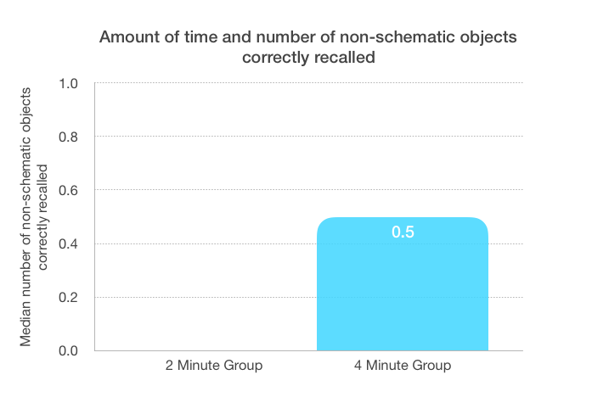
Since our experimental design had independent measures and used ordinal-level variables, our group used the Mann-Whitney U test which is a nonparametric test. Our critical U value for the Mann-Whitney U test at the 5% significance level is 23. Our observed U value is 37.5. Thus, since our observed U value is greater than the critical U value, we can say there is not a highly significant difference between the number of non-schematic items remembered in terms of how long the participants stayed in the room. Based on the previous statement, my group fails to reject the null hypothesis.

Evaluation
Although there were more non-schematic objects correctly recalled in the four-minute group, there is not a significant difference in the results to come to the conclusion that time affects the amount of non-schematic objects recalled. Therefore, if Brewer & Treyens left their participants in the room for a longer period of time, it would not have had a notable impact on the results. Disregarding time, our findings paralleled Brewer & Treyens’. In the original study, Brewer & Treyens’ (1981) found that participants recalled the schematic objects, the non-schematic objects (because they were unusual), and other objects that fit the schema but were not actually in the room. Our findings were the same! People recalled items that fit with schema (like the tables and chairs). They also reported the non-schematic items because they were unexpected (like the bike and the laundry). Similar to the experiment by Brewer & Treyens, some participants “recalled” classroom objects that were not actually in the classroom due to their schema about classrooms. Therefore, even though we failed to reject our null hypothesis about time as the independent variable, what we found as a whole supports the previous study by Brewer & Treyens.
Although we did our best, our experiment still had some limitations. It was a difficult task in trying to get the participants to notice their surroundings in the classroom. Therefore, we played silent ball as a form of deception. Although the participants were able to look around the room, they paid more attention to winning at silent ball instead. It was challenging to find ways to make them notice their surroundings without making it obvious. Another limitation is the amount of time some people stayed in the room. For example, some participants were able to enter the room a couple of seconds before others. Additionally, some participants left a couple seconds earlier. That means that the time the participants were in the room may not have been exactly two or four minutes. There was no way to control for this, so it may have affected our independent variable. A limitation in our sample was the lack of variety in participants. Due to convenience sampling, it was difficult to get participants outside of our school, which means our findings cannot be generalized to the whole population. Instead, our findings only representative of students aged 15 to18 that attend our high school.
Although our experiment had limitations, it also had strengths. Since we separated the two groups and did not let them communicate, the knowledge was not shared so no one had an advantage when writing down the recalled objects. A strength of our sample was that all of the participants were IB or pre-IB students. This means that they listened attentively and followed all directions so that our experiment would have accurate data. A strength of the design was the classroom chosen. To pick our experimental classroom, we chose a room that none of the participants were familiar with. That is because if we used a classroom we all had before, then the non-schematic items would stand out more.
If I were to repeat this study, I would make some modifications. Instead of playing silent ball to notice the surroundings, I would have the participants take part in a scavenger hunt. The objects chosen to be in the scavenger hunt would then not be counted when participants write down all of objects they recall. I would expect to see more objects recalled (both that fit and do not fit with schema). I would also make a modification to study a different aspect of the topic: target population. Instead of putting students in a classroom who are already familiar with what American classrooms look like, I would choose a group of people not familiar with American classrooms. For example, I would choose teenagers from other countries that have never went to school. Since they do not have any previous knowledge (schema) of classrooms, I expect that they will pay more attention to their surroundings. Therefore, I expect that these teenagers would be able to recall more objects (both those that fit with schema and those that do not).
In conclusion, time did not have an impact on the number of non-schematic objects recalled. However, we did notice some similarities to Brewer & Treyens’ findings. Disregarding time, participants from both groups recalled schematic objects. They also recalled non-schematic objects because they were surprising. Some participants even “recalled” some objects that were not actually in the room due to their schema. Overall, although time was not an important factor, some of our other findings comply with Brewer & Treyens’ findings.

References
Brewer, W. and Treyens, J. (1981). Role of schemata in memory for places. Cognitive
Psychology, 13(2), pp.207-230.
Loftus, E. and Palmer, J. (1974). Reconstruction of automobile destruction: An example of the
interaction between language and memory. Journal of Verbal Learning and Verbal
Behavior, 13(5), pp.585-589.

Appendix I: Parental Consent Form
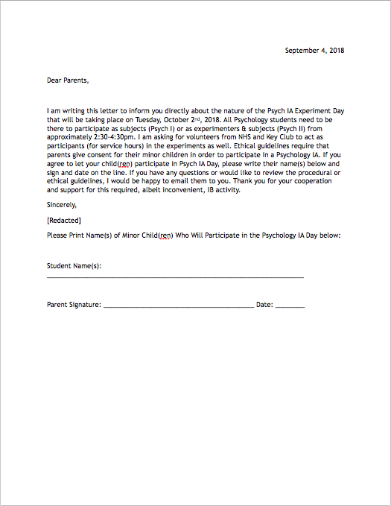

Appendix II: Informed Consent Form
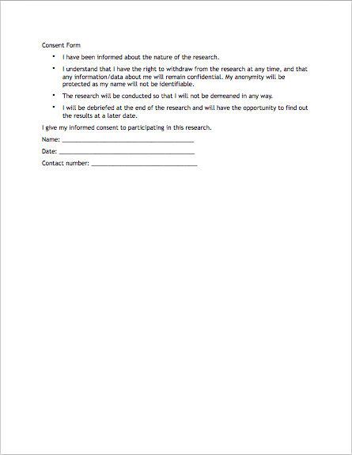

Appendix III: Standardized Instructions
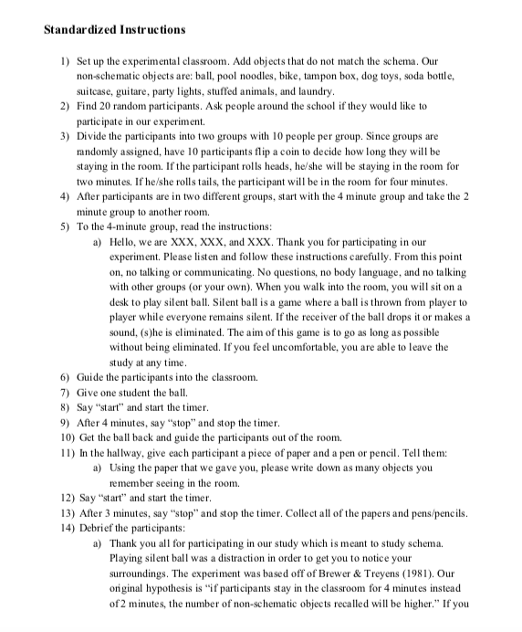
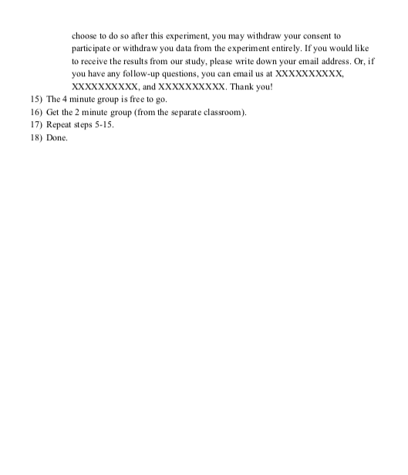

Appendix IV: Raw Data
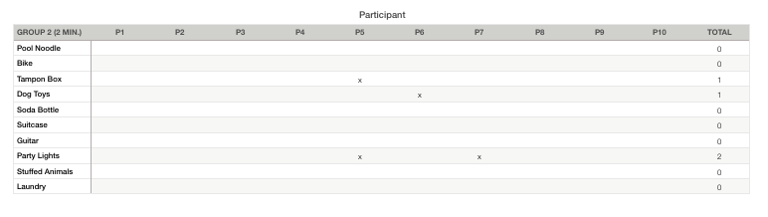
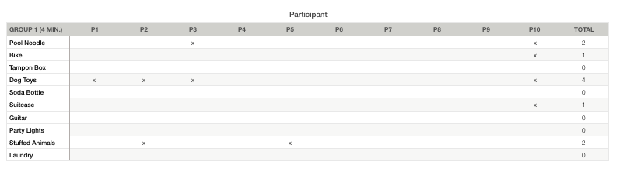

Appendix V: Statistics and Calculations
