Introduction
The way we perceive knowledge is a significant factor in how we use it. So, a way to make people perceive knowledge more positively holds large significance in knowing how people interpret and act on knowledge. One proposed theory of such cognitive bias is the halo effect, named such by psychologist Edward Thorndike (Halo Effect, n.d.) in reference to a person being perceived as having a “halo” due to bias caused by factors such as attractiveness in judging a person.
Other studies have taken this idea further to apply to the inanimate, such as the study “Doing Well by Doing Good: The Benevolent Halo of Corporate Social Responsibility” by Alexander Chernev and Sean Blair (Chernev and Blair, 2015) focusing on perception of products and companies. Their experiment had two groups taste identical wines and be given identical information, except for one detail in the information being added to the experimental group, being that the winery donated 10% of proceeds to the American Heart Association. The results showed that “analysts at mean levels of expertise revealed that respondents who were aware of the winery’s monetary donations to a charitable cause rated the wine as tasting better”, with the average rating being 5.07 on a 1-9 Likert Scale for the experimental group versus 4.36 for the control. The study concluded that “acts of corporate social responsibility can strengthen consumer evaluations of the functional performance of company products” (Chernev and Blair, 2015).
The aim of our study is to see if such a halo effect would significantly improve the perception of a company, rather than a person or product. This experiment holds significance because of how the halo effect can change people’s perceptions, viewpoints, and actions through different information. It could be used to alter advertising trends and make people aware of such trends and how they could be affected. Our experiment has been altered from Chernev and Blair’s to fit our setting and target. Rather than wine, we had subjects watch the same Walgreens commercial (Appendix 1), which included information about donations to children in poverty. The experimental group watched the unchanged commercial, while the control watched the commercial muted to not give the positive information. These changes allow us to observe the halo effect’s connection to perception of an entity (for us, Walgreens) over an object as Chernev and Blair tested.
Our experiment links to Chernev and Blair’s findings of monetary donations to a charitable cause causing people to perceive something positively. However, our experiment, while partially replicating Chernev and Blair’s experiment by having subjects rate an object to observe the halo effect, we tested if the halo effect could alter how somebody perceives an abstract entity, such as a company. We use Chernev and Blair along with the basis of the halo effect to investigate what positive information does to perceptions.
The null hypothesis is that the independent variable, information regarding charitable donations, will have no significant effect on the dependent variable, person’s perception of a company. The research hypothesis is that participants who given information of charitable actions by a company, the independent variable, will have a more positive perception, the dependent variable, of the company. To show these, we presented each group with the same video, but the experimental group was informed of charitable donations by the company in question in the commercial while the control was not. The halo effect would be shown if participants in the experimental group perceive the company in question more significantly when only a positive charitable action is added to an advertisement compared to the control. The perceptions are operationalized by the participants in both group’s ratings of the company on a 1-10 Likert scale.
The independent variable is the information in the commercial: the experimental group being given information about charitable donations from a company and the control having such information withheld, operationalized by the information we provided to each group through the video. The dependent variable is the reported perception of the company from the subjects and operationalized on a 1-10 Likert scale.

Exploration
This experiment was designed to use independent measures, where two different sets of participants were used, one for each condition. We chose these measures not only to follow our basis, but also to be able to see the difference in perception when philanthropy is included or not rather than added after. The design was set to control that one group would have no preconceived notion of what they would be watching, or what alterations may have been made, ensuring no bias. The sample was made through convenience. We used this method as it was the easiest way to get participants from a target population that would not only allow them to understand the experiment and keep ethical considerations in place, but also be one of the most significant populations this experiment’s results could impact. It was composed of 20 IB students of grade levels 9-12, 10 in the experimental group and 10 in the control. This group, while chosen by convenience, is also a good target population because of the likelihood of them having experience with similar advertising. Each group was given the same questions. Before the experiment, each participant was given a consent form and notified of their ability to withdraw (App. 2). As all participants were minors, they also required a parental consent form (App. 3). At the end, they were all debriefed of the basis and reason of the experiment and what each group was shown (App. 4).
To decide on an advertisement to use, we had to first select one that could be easily altered to not significantly change the commercial. In addition, it had to be related to a positive cause in order to create a halo effect but could not have any overlaying text on screen about it, or it would be significantly harder to hide. We chose a minute long commercial with mostly generic imagery for Walgreens to suit the purpose that fit all these criteria and could be played and muted so the positive cause could be hidden.
We randomly selected the groups and their position as control or experimental. In addition, we also used a sticky note on the projector to hide the video title for the control, ensuring they were unaware of the video’s purpose. The subjects were asked not to discuss the video until their responses were collected. The video was played for the control and independent for the same timeframe, and they were given a set of questions to respond to after (App. 5). The questions consisted of 5 distractors asking about their knowledge and previous conceptions of the video, and the main question, asking about how positively or negatively they saw the company based on the commercial on a 1-10 Likert scale, 1 being very negative, 5 being neutral, and 10 being very positive. Each group was then given about 6 minutes to respond to the questions. After the questions were filled out, the papers were collected, and they were asked to leave silently. The first group was asked not to speak to the other group.
Once the questions had been filled out, the papers were collected. When both groups were done, both groups were invited back in and debriefed (App. 4).
This experiment had variables which could have altered the outcome, most significantly being if members of the control were aware of previous positive donations made by Walgreens beforehand.
Analysis
After collecting and tallying all data (App. 6), inferential and descriptive statistics were calculated to check for significance of the data.
The descriptive statistics have been outlined in the table below:
 | Control | Experimental
Mean | 7 | 7
Interquartile Range | 2.5 | 2

These types of descriptive statistics fit the ordinal data collected, helping to accurately show the differences between the two groups in data.
The following graph compares the medians of the two groups:

The medians of the experimental group and control group matched, meaning both the experimental group and control group showed some preference to the company, but being presented with a charitable cause did not alter the preference significantly, supporting the null hypothesis. The median score remaining the same potentially indicates the amount of significance to be negligible. The higher interquartile range in the control shows variance in answers, however, supporting the research hypothesis because there was less influence trending upwards for the control.
Because we used an independent sample design with ordinal data, we used a Mann Whitney U inferential statistics test (App. 7). The test was one-tailed as we expected members of the experimental group to trend higher on their perception of the company. The U value of 44 exceeds the critical values at .01% (19) and .05% (27). Thus, we fail to reject the null hypothesis.
Evaluation
While we found some relation to the results of Chernev and Blair through our descriptive statistics in our study, it can be seen from our results that we were not able to find a significant link to philanthropy and better perception of a company through our experiment as a U value of 44 exceeds the critical values. It appears other factors take precedence when determining perception of a company. This could be because the halo effect may only effect physical objects, such as the wine Chernev and Blair studied or the people in the original Thorndike study.
The rationale of our experimental hypothesis is that positive information would correlate with positive perception. However, giving students information regarding something does not effectively change how they see it according to our study.
There were significant limitations to our study which may have affected how it turned out, however. By using a well-known company and possibly seen before advertising campaign, there was a chance that some of the subjects would have seen the commercial, or one like it, beforehand, altering the effectiveness of the experiment as they would already have had their perceptions altered, potentially inflating scores of the control group.
One other limitation was needing to silence the donation portion of the advertisement, potentially altering the experience of the control significantly compared to the independent. Because our goal was to keep the two experiences as close as possible to be accurately compared, this limitation could make that comparison difficult. With these two limitations in mind, the ideal changes we would make to our experiment if ran a second time would be to bring an obscure or possibly fake commercial as the independent variable.
Another limitation of note was our sample. As it was composed of a general student demographic, it is a generally non-representative sample, as they not only share similarities due to age, but as they are all from the same location, likely share similar socioeconomic backgrounds and culture, and thus is harder to apply to larger and more different groups or cultures.
However, there are also significant benefits to our style of experiment. One important one is the ability to directly compare the two because of the similarities of the two commercials, as the changes made were very minor. This allows us to directly gauge the effect of the halo effect with very few other factors making effects to the data. This is helpful as it allows our experiment to control for some extraneous variables more easily and make direct comparisons between the two groups.
Another strength is the simplicity of the experiment for the subjects – there were no spaces left empty and very few questions, meaning they most likely understood and gave the most accurate responses they could.
One final significant strength is in our sample, as they are not only convenient to collect data from, but also are likely to understand the questions of the experiment. Due to their age and culture, they are also likely a key demographic of this experiment and examining the applications of charity in advertising.
Our experiment also differed from Chernev and Blair in some operational ways, but these are justified to be able to effectively assess perception of the abstract rather than an object with the Halo Effect. For example, we used a commercial instead of wine, and asked participants to rate perception over something sensory like taste. In the scope of our IA, we could not use wine nor any food, and wanted to rather observe the perception of a company. Thus, our changes were able to look into a new avenue. But, to change it further if not limited by said scope, showing participants multiple companies and statistics, adding charity as one of said statistics, and seeing how people perceive them while using both before and after statistics could give valuable insight as to how the halo effect could change perception rather than alter it.
While other studies have shown the halo effect’s power over perception of the physical, it appears it does not have a significant effect on how people perceive corporations and groups. Replicating the experiment further with more effective comparisons between the control and experimental may help us see the influence, or lack thereof, of the halo effect more clearly, understanding the halo effect’s contributions to cognitive bias may help us see what influences it provides to how we see companies and groups.

Works Cited
Chernev, A., & Blair, S. (2015). Doing Well by Doing Good: The Benevolent Halo of Corporate Social Responsibility. Journal of Consumer Research, 41(6), 1412-1425. doi:10.1086/680089
Halo Effect. (n.d.). Retrieved October 16, 2018, from https://psychology.iresearchnet.com/social-psychology/social-cognition/halo-effect/

Appendices
Appendix I. Commercial Displayed to Subjects

https://www.youtube.com/watch?v=ELImy8iK9nM

Appendix II.
Consent Form Sample
- I have been informed about the nature of the research.
• I understand that I have the right to withdraw from the research at any time, and that any information
• Data about me will remain confidential. My anonymity will be protected as my name will not be identifiable.
• The research will be conducted so that I will not be demeaned in any way
.• I will be debriefed at the end of the research and will have the opportunity to find out the results at a later date.
I give my informed consent to participating in this research.
Name: ________________________________________
Date: _________________________________________
Contact number: ________________________________

Appendix III. Parental Consent Form Sample

Dear Parents,

I am writing this letter to inform you directly about the nature of the Psych IA Experiment Day that will be taking place on Tuesday, October 2nd, 2018. All Psychology students should be there to participate as subjects (Psych I) or as experimenters & subjects (Psych II) from approximately 2:30-4:30pm. I am asking for volunteers from NHS and Key Club to act as participants (for service hours) in the experiments as well. Ethical guidelines require that parents give consent for their minor children in order to participate in a Psychology IA. If you agree to let your child(ren) participate in Psych IA Day, please write their name(s) below and sign and date on the line. If you have any questions or would like to review the procedural or ethical guidelines, I would be happy to email them to you. Thank you for your cooperation and support for this required, albeit inconvenient, IB activity.
Sincerely,
[REDACTED]
Please Print Name(s) of Minor Child(ren) Who Will Participate in the Psychology IA Day below:

Student Name(s): ______________________________________________________________________

Parent Signature: _________________________________________________________ Date: ________

Appendix IV. Standardized Debrief Script

“So, what you all experienced was a commercial from Walgreens advertising Red Nose Day, a charity by the company to help the poor. Now, if you were part of the first group, you likely didn’t know this, as nothing audio or visual told you. The purpose of this was to test the halo effect, a concept originally created by psychologist Edward Thorndike, on how it made you feel. The halo effect, in essence, states that positive seeming features cause people to perceive others as better, regardless of if they really are better or not. The aim of our test and the questions was to see if the group who knew about the charity had a more positive idea about Walgreens as a whole compared to those who did not. This is important to us in order to see if advertisers can influence people using such tactics effectively. Please feel free to ask any questions, and if not, you are free to go.”

Appendix V. Questions Asked to Subjects
On a scale of 1-10, how positively or negatively did you see the company prior to seeing this commercial?

Very Negatively Neutral Very Positively
1 - - - - - - 2 - - - - - - 3 - - - - - - 4 - - - - - - 5 - - - - - - 6 - - - - - - 7 - - - - - - 8 - - - - - - 9 - - - - - - 10

On a scale of 1 – 10, how positively or negatively do you see this company based this commercial?

Very Negatively Neutral Very Positively
1 - - - - - - 2 - - - - - - 3 - - - - - - 4 - - - - - - 5 - - - - - - 6 - - - - - - 7 - - - - - - 8 - - - - - - 9 - - - - - - 10

What was most significant to you about this commercial?

Do you consider this commercial effective?

Did you have any (even if limited) knowledge of what this commercial was advertising before you watched it?

If yes, please indicate in as much detail as possible.

Appendix VI. Raw Data
Control Data
K |  | 6
L |  | 8
M |  | 8
N |  | 8
O |  | 7
P |  | 8
Q |  | 5
R |  | 6
S |  | 7
T |  | 5
Median: 7
Ind. Data
A |  | 6
B |  | 7
C |  | 5
D |  | 8
E |  | 8
F |  | 9
G |  | 8
H |  | 7
I |  | 6
J |  | 7
Median: 7

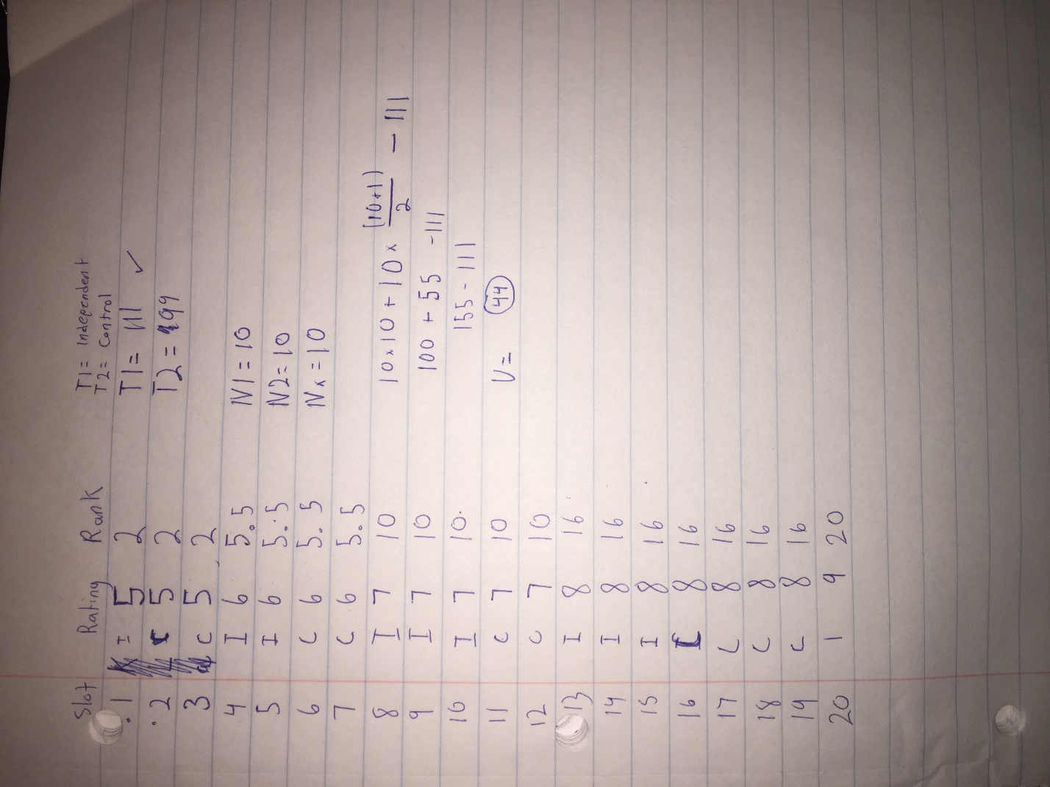
Appendix VII. Mann-Whitney U Calculations and Critical Values

