Investigation on Availability Heuristic in Judging and Probability
Independent Measures
Availability Heuristic
Candidate Code: hhn585
Group Member’s Candidate Code: hhn541
Date of Submission: 10/18/18
Word Count: 2,191Words

Introduction:
The aim of this investigation was to research to what extent prior estimations of one’s abilities influenced their ability to produce words based off of a restriction. We based our study on Availability: A Heuristic for Judging Frequency and Probability(Tversky and Kahneman, 1973). The original study contained seven subset studies, from which we chose Study 1, the Construction study, to base our investigation on (Appendix 1).
This aim was to test the effect of availability on one’s judgment and speed of their corresponding response. The researchers tested this by providing a random sample with 8 problems containing 9 letters from which the subjects were asked to create 3 or more letter words out of. Each subject of the experimental group was first provided with 7 seconds to estimate the number of words which they believed they could produce in 2 minutes. Following this, they were given the 2 minutes to write down however many words they could create from the 9 letters. The data from this round was discarded and dubbed the trial run.
For the official run, the experimenters followed the same procedure and allotted each subject the original 7 seconds to estimate and 2 minutes to produce 3 or more letter words from the given 9 letters. Following this, they were asked to complete the control portion of the research, by not estimating the number of words they could produce in 2 minutes and directly producing the words they could. This data was then compared to his personal list of the maximum number of words created prior to estimation. The participants were split into two sets of subjects, with half estimating prior to creating the word, and the other half directly constructing the words.
With this study, the researchers tested the Availability Heuristic theory, specific to representativeness. An Availability Heuristic is a mental shortcut used to complete a given task. This shortcut relies on immediate examples that come to one’s minds when evaluating a specific topic. It’s by this process whereby people make judgments about the likelihood of an event. Through Study 1, the research “[F]irst demonstrate[d] that people can assess availability with reasonable speed and accuracy” (Tversky and Kahneman, 1973). The set of provided letters acted as the limits to availability, which placed the boundary on the subjects.
The mean number of words produced from the following 2 sets of 9 letters: XUZONLCJM and TAPCERHOB, produced between 1.3 and 22.4 words respectively. The mean number of words produced following estimation was 11.9 words per subject. The estimated number of words varied from 4.9 to 16.0 words respectively. The mean estimated number of words was 10.3 words per subject.
The conclusion based on Study 1, which was analyzed in correspondence to Study 2: Retrieval, stated that, “[T]he availability of instances could be measured by the total number of instances received or constructed in a given problem”(Tversky and Kahneman, 1973). In summation, they believed that the subjects used prior experiences to judge the probability of the number of words they could create in this situation. The initial estimates also unknowingly influenced the subject’s results through the Anchoring and Adjustment Heuristic which proposes that many estimates are based on known anchors, or familiar positions. While this was more thoroughly discussed in the latter studies, it was an element in this study as well.
The main variation from the original study was seen in our addition of 2 separate groups and in providing only 1 set of letters for the groups to compose from. We originally split the groups to provide a standard of comparison. Along with this, splitting our groups allowed us to use 1 set of letters since we did not need to reduce repetition. The split groups allowed us an easier way to reach a conclusion on our hypothesis.
While the aim of our experiment was the same as the original study, our hypothesis was more specific to our alteration. Our hypothesis was that the group who estimated the number of words they would produce would create a higher number of words than the group that did not estimate the number of words they would produce. Our null hypothesis was we predicted that the group that did not estimate the number of words they would produce would create a higher number of words than the group that did estimate the number of words they would produce. We tested our research hypothesis with the Independent Variable: the type of task the subject participated in (estimation of 3 or more letter English words without the 7 seconds of estimation of number of words you can compose in 2 minutes and estimation of 3 or more letter English words with the 7 seconds of estimation of number of words you can compose in 2 minutes) and the Dependent Variable: the number of 3 or more letter English words produced in 2 minutes from the given 9 letters, with no repetition of letters.

Exploration:
Our study utilized independent measures to, as previously mention, allow us to utilize one common list of letters without providing advantages to either of the groups. This design allowed us to have multiple groups, which ensured that the certain letters we provided were not the cause for fluctuation in our data, and using independent measures allowed us to do so. Our study was conducted under convenience sampling, since it was held in a small setting with limited available participants. The participants contained of 15-17 year old, native English speaking, high school kids. Selection for specific groups was later randomized. Our target population was a random selection of students who volunteered to be subjects for any study under prior parental consent. This was done due to the setting of our research.
As previously mentioned, we based our study off of Study 1 of Tversky and Kahneman’s original research. Maintaining a similar approach, we tested with some minor alterations. While the original study used 1 common set of participants, we split our 20 member convenience sample into two equal groups through a random selection method of counting off. Following this, we designated the first group “Control Group” and the other “Experimental Group”. Both groups were given the same papers with the same 9 provided letters: ASIPJEHMR. The first group, the Control Group, was seated and given 2 minutes to produce English words composed of 3 or more letters, with no repeated letters. They were asked not to discuss the procedure with any of the participants. Following this, the second group, the Experimental Group, was seated and provided 7 seconds to estimate the number of 3 or more letter English words they could compose out of the 9 provided letters in 2 minutes without repeating any letters. They were then asked to write this number on the back of the provided test sheet before they were allowed to flip the paper. These subjects were provided the same 2 minutes to compose English words composed of 3 or more letters, with no repeated letters. Once the Experimental Group completed composing, we invited the Control Group back in to debrief them.
While our study ran smoothly, there were some extraneous variables we needed to control prior to running the study. One of these included the subjects’ pens running out of ink or them running out of space on the paper. To account for this, we provided each table with a large supply of pens, which we previously tested. Along with this, we placed some extra copies of the test sheet in case the subject required more space or damaged their original copy. One of the main factors we had to control for was the subject’s familiarity with the English language. While this was more difficult, due to our convenience sampling method, once selected we ensured with each member that they were fluent in the English language. Any members who were not would have been requested to leave the study and be randomly replaced in order to ensure that language barriers did not influence the rate and result of their word production.
Keeping ethical considerations in mind, we began this study with all given subjects and their parents signing a Consent Form provided by our teacher (Appendix 2). Only then were they allowed to be a subject in the studies. For our specific study, we began by requesting each subject to fill another Consent Form (Appendix 3). Along with this, they were all informed that they had the right to withdraw themselves and their data from the study at any given time. Following the testing, all 20 members were debriefed (Appendix 4) and once again reminded of their right to withdraw any data.

Analysis:
The control group’s (those who did not estimate) median was 9.5 words/person. The experimental group’s (those who did estimate) median estimation was 7.5 words and the number of words actually produced was 12 words. The Interquartile Range value for the overall data was 7.5 words. The IQR being relatively lower, suggests that our data does not consist of any notable outliers. The medians support our original hypothesis, as those who made prior estimations produced a higher number of words than they estimated and the control group. The experimental group constructed 4.5 words greater than they had estimated, and 2.5 words greater than the median of the control group. The specific results of our study, as well as the graphical representations can be referenced in Appendix 5.
We chose to utilize the median and the IQR as our descriptive statistics to minimize the effects of external conditions on our data. Using these methods took the possible outliers into consideration, and eliminated the extent to which they affected our overall data.
Graph 1: Subject vs # of 3+ Letter English Words Produced from the Given 9 letters in 2 Minutes
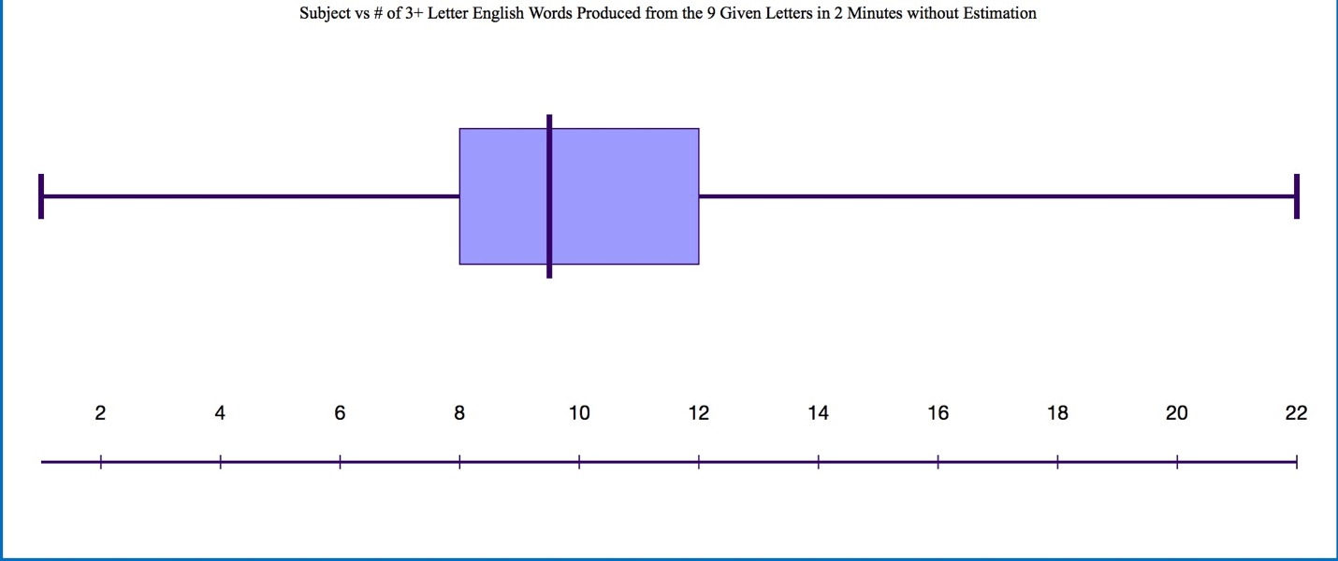
Graph 2: Subject vs Estimated # of 3+ Letter English Words Produced from the Given 9 Letters in 2 Minutes
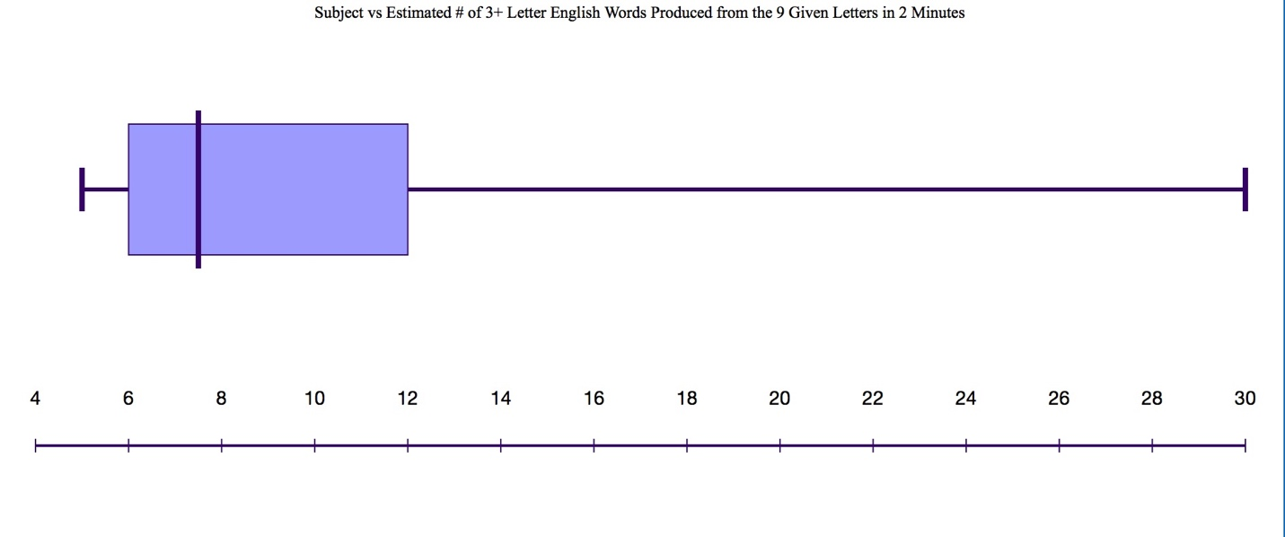
Graph 3: Subject vs # of 3+ Letter English Words Produced from the Given 9 Letters in 2 Minutes with Estimation
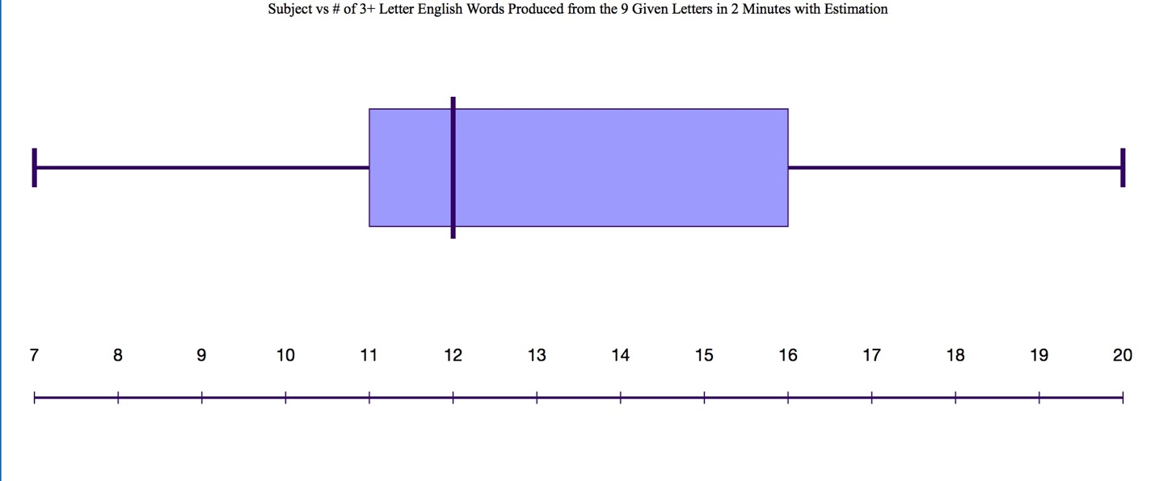
Through utilizing the Mann Whitney U test, I solved and found the u value of our study to be 33 words (Appendix 6). Once I compared this to the Critical Values chart, I derived that our study’s data was not significant. This was because, on the 0.05 scale, our value was greater than the given value of 27. We chose to use this method with our ordinal data because of the experimental design using independent measures. Utilizing this form of inferential stats ensured that both sets of subjects, and their respective conditions, would be analyzed individually.
Our inferential test results suggest that our data is insignificant, which may be due to external factors, such as participant speed, which we could not cover for, affected this. However, based on our data, we concluded that our hypothesis was accepted as those who made estimations were able to produce more words than those who did not.
Evaluation:
Our data (Appendix 5) suggests that our hypothesis was accepted, as those who made prior estimations were able to create a larger number of 3 or more letter English words out of the 9 given words in 2 minutes than those who did not estimate. Along with this, they often beat their estimations. This suggests that the availability heuristic trait was more prevalent in those who had time to estimate prior to creation. The added 7 seconds provided the subjects with time to connect this instance to a similar instance, in which they completed a task much like this one. Based on this, they were able to create an estimation, which they then subconsciously set to beat or tie. Similar to the original study, the members of our group who estimated produced a higher number of words than their estimation and those who didn’t. Both studies being conducted in native-English speaking environments increased the likeliness between results.
Splitting our data between a control and experimental group was a strength to our experimental design, as it allowed for easier data comparison. We were able to analyze the effect of prior estimation more clearly. Along with this, keeping the set of 9 letters constant between both the control and experimental group was a benefit to our study. This kept a constant to our comparison. However, the set of letters the participants received may have influenced their ability to produce words.
If we were to replicate this study, I would change factors of the design to remove limitations. One I noted was that some subjects would not utilize the whole time to create words, and instead would stop early. The net limitation was within the sample size. In the future, I would use a larger sample size to control for both of these limitations.
In the future, to improve this current IA study, I would alter the study by having more experimental and control groups, specific to different sets of letters, to test if the availability of vowels or consonants altered the extent to which the availability heuristic was seen within the subject. Furthermore, I would alter the factor the subjects recalled. In this study, I would provide the control group with a list of categories, which once read, they would be given 2 minutes to write down and recall. The experimental group would be provided 7 seconds to estimate how many categories they could retrieve in 2 minutes, before being read the list. Next, they would be given 2 minutes to recall the categories. This study would take a more specific approach to understanding availability heuristic.
From our study, we are able to conclude that prior estimations and reference to prior situations present a larger availability heuristic trait than in those who perform without estimation.

References
Tversky, A., & Kahneman, D. (1973). Availability: A heuristic for judging frequency and
probability. Judgment under Uncertainty,163-178. doi:10.1017/cbo9780511809477.012
Reisberg, D. (2018). Cognition: Exploring the science of the mind. Retrieved October 18, 2018,
from http://wwnorton.com/college/psych/cognition5/ebook.aspx

Appendix 1: Study to be replicated
Title: Availability: A Heuristic for Judging Frequency and Probability
Authors: Amos Tversky and Daniel Kahneman
Link to study: https://msu.edu/~ema/803/Ch11-JDM/2/TverskyKahneman73.pdf

Appendix 2: Original participant parent consent form provided by supervisor

September 4, 2018

Dear Parents,

I am writing this letter to inform you directly about the nature of the Psych IA Experiment Day that will be taking place on Tuesday, October 2nd, 2018. All Psychology students need to be there to participate as subjects (Psych I) or as experimenters & subjects (Psych II) from approximately 2:30-4:30pm. I am asking for volunteers from NHS and Key Club to act as participants (for service hours) in the experiments as well. Ethical guidelines require that parents give consent for their minor children in order to participate in a Psychology IA. If you agree to let your child(ren) participate in Psych IA Day, please write their name(s) below and sign and date on the line. If you have any questions or would like to review the procedural or ethical guidelines, I would be happy to email them to you. Thank you for your cooperation and support for this required, albeit inconvenient, IB activity.
Sincerely,
[Redacted]
Please Print Name(s) of Minor Child(ren) Who Will Participate in the Psychology IA Day below:

Student Name(s): ______________________________________________________________________

Parent Signature: _________________________________________________________
Date: ________

Appendix 3: Consent form provided to subjects specifically participating in our study
Consent Form
- I have been informed about the nature of the research.
- I understand that I have the right to withdraw from the research at any time, and that any information/ data about me will remain confidential.
- My anonymity will be protected as my name will not be identifiable.
- The research will be conducted so that I will not be demeaned in any way.
- I will be debriefed at the end of the research and will have the opportunity to find out the results at a later date.
I give my informed consent to participating in this research.
Name: ___________________________________________
Date: ____________________________________________
Contact number: ___________________________________

If you have any questions or would like to learn about the results, please email [removed names and emails of study conductors]

Appendix 4: Debriefing procedure received by all 20 subjects following the end of the study

The experiment we just performed on you was to test for the Availability Heuristic. As you can see, we had two groups go in at different times. The first group was the control group and the second was the experimental group. You were both given the same paper, but the experimental group was given 7 seconds, before composition, to estimate the number of the 3+ letter English words they could compose from the provided 9 letters that they could create. The control group and the experimental group were given the same word bank and same amount of time, 2 minutes, to compose the 3+ letter English words out of the 9 provided letters. We are going to compare the data from the two groups to evaluate if creating a prior estimation had any effect on the amount of words composed. Our hypothesis was that the group that estimated would produce a higher number of words due to the heuristic. After hearing this information, if you would like to withdraw your data from the results, you are free to do so. Thank you so much for participating in our psychology IA study. If you would like the results of our study, our emails our on the board and you are free to contact us.

Appendix 5: Specific subject data received from study
Control Group Data:
Group asked to directly compose 3 or more letter English words from the provided 9 letters in 2 minutes.
Subject | # of Words Created*
A | 1
B | 9
C | 17
D | 22
E | 10
F | 9
G | 12
H | 7
I | 8
J | 10

Experimental Group Data:
Group given 7 seconds prior to estimating to estimate the number of 3 or more letter English words they could compose in 2 minutes from the provided 9 letters.

Subject | Estimated # of Words | # of Words Created*
K | 12 | 16
L | 8 | 16
M | 30 | 20
N | 17 | 12
O | 8 | 8
P | 7 | 12
Q | 6 | 12
R | 5 | 7
S | 6 | 11
T | 5 | 17

Appendix 6: Method of solving inferential statistics (Mann Whitney U test)
Experimental Group:
A 16
B 16
C 20
D 12
E 8
F 12
G 12
H 7
I 11
J 17
TOTAL: 10 groups

Control Group:
K 1
L 9
M 17
N 32
O 10
P 9
Q 12
R 7
S 8
T 10
TOTAL: 10 groups

Arrange lowest to highest:
Subject | K | R | H | E | S | L | P | O | T | I | D | F | G | Q | A | B | T | M | C | W
Rank # | 1 | 2.5 | 2.5 | 4.5 | 4.5 | 6.5 | 6.5 | 8.5 | 8.5 | 10 | 12.5 | 12.5 | 12.5 | 12.5 | 15.5 | 15.5 | 17.5 | 17.5 | 19 | 20
T₁: 122 words
T₂: 88 words
T_{n}: 10 subjects
U₁= 10(10)+10(11/2)-122; U=33 words

Critical Value:
0.05= ≤27
Our U value: 33 is > ∴ NOT SIGNIFICANT

Appendix 7: Test paper provided to subjects

Psychology IA
[Omitted names of study conductors]
Letter Bank:
ASIPJEHMR

Composition of Words:

Appendix 8: General followed procedure
Psychology IA
Before Experiment:
Hello everyone, we are [Omitted names] . Thank you for volunteering for our psychology IA
- Control Group/Group 1:
-Please find a seat, and do not sit right next to anyone.
-Please do not turn your papers over until we are finished with the directions.
-You will have 2 minutes to write as many words as you can from this 9-letter bank of letters.
-These words must be 3 or more letters long, and can only include the provided 9 letters. These words also much be in English.
-You are free to leave the study at any time.
-Any questions? Time starts now.
-*After 2 minutes* put your pencils down and count the amount of words you composed.
-Please do not talk to the other group about the experiment, we will call you back in after the experiment.
- Experimental Group/Group 2:
-Please find a seat, and do not sit right next to anyone.
-Please do not turn your papers over until we are finished with the directions.
-You will have 7 seconds to estimate the amount of words you can guess from this 9-letter bank of letters. Write the estimated number on the back of the paper.
-These words must be 3 or more letters long, and can only include the provided 9 letters. These words also much be in English.
-You now have 2 minutes to compose as many words as you can.
-You are free to leave the study at any time.
-Any questions? Time starts now.
-*After 2 minutes* put your pencils down and count the amount of words you composed.

After Experiment: Debrief
- Refer to Appendix 4 for Debriefing procedure.

