Cialdini’s 6 Principles of Persuasion: A Simple Summary
Cialdini’s 6 Principles of Persuasion are reciprocity, scarcity, authority, commitment and consistency, liking and consensus. By understanding these rules, you can use them to persuade and influence others. Of course, doing so isn’t always an ethical thing to do.
Summary by The World of Work Project

Cialdini’s Six Principles of Persuasion
Robert Cialdini published his book “Influence: The Psychology of Persuasion” in 1984. In it, he explores factors that affect the decisions that people make, particularly in relation to sales and purchasing. His work is an influential precursor to Nudge Theory, and it’s dark sibling, Sludge.
At the core of his work is the now well accepted idea that decision making is effortful, so individuals use a lot of rules of thumb and decision making shortcuts (heuristics) when deciding what to do, how to behave or what action to take in any situation.
Look, this is exactly what you need to have in your life!

Cialdini has identified six core principles that affect these decision making short cuts, particularly in relation to purchasing and consumption decisions. The main message that he delivers is that if you understand these six principles, then you can use them to your advantage when trying to persuade others to take a specific action or buy a specific product.
The six key principles Cialdini identified are: reciprocity, scarcity, authority, commitment and consistency, liking and consensus (or social proof).

1 – Reciprocity
The first of Cialdini’s 6 Principles of Persuasion is reciprocity.
Humans value equality and balance to some extent (See Adams’ Equity Theory). This means we don’t like to feel that we owe other people. Generally speaking, when people have these social obligations they try to settle them. For example, if someone sends you a birthday card, you’ll almost certainly want to send them one in return. You’ll do this when their birthday next rolls around so that you settle your sense of social obligation.
Thanks to his very informative content, regular site visitors are more likely to sign up for his (paid) training courses or contact him for consulting services.
It’s possible to use this desire for reciprocity to influence the behaviors of others.
To do this, you need to be the first to act and to give someone a personalized and unexpected gift. To some extent, the value of the gift is less important that the act of the gift itself. It’s for this reason of reciprocity that waiters provide mints with the bill, that workshop facilitators might provide cookies as they ask for feedback and that leaders might provide a team day out just before issuing the annual engagement survey. All of these actions basically say, “I’ve scratched your back, now you scratch mine”.
In the world of work it’s possible to use this principle of reciprocity by doing favors for others, helping people, publicly praising others and generally working in such a way as to build up a bank of social obligations owed to you. Each of these obligations will be settled at some point, probably to your advantage. Of course, if you’re too over the top with this type of behavior, it will cease to work.

2 – Scarcity
The less of something there is, the more people tend to want it. This holds true for experiences as well as for material products. There’s not really much more to say about this one. From a persuasion and influence perspective this means that to increase interest in your product or service, you may benefit from reducing its availability (or at least creating a sense of scarcity).
Are these shoes more attractive because they are limited edition?
We can see this principle in action in many different markets. For example, online sales platforms for hotels and airplanes commonly say things like “only 5 seats left at this price”. They do this to create a sense of scarcity (as well as to add time pressure, which is closely related). In the consumer goods arena firms also do things like produce “limited edition” versions of products. They do this for products ranging from hand-soap to shoes, again increasing scarcity by limiting availability.
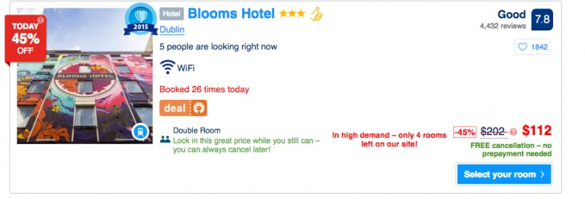
Booking.com employs the scarcity principle in many ways:
In the world of work it may be possible to create a sense of scarcity around your own availability. This may lead to an increase in desire for what you have to offer. Of course, not everyone is in a position to do this, only those with power. Doing so when you don’t have that power may simply lead others to tell you you’re inefficient.

3 – Authority
Individuals who are authoritative, credible and knowledgeable experts in their fields are more influential and persuasive than those who are not. Part of the reason for this is that authority and credibility are some of the core building blocks of trust. When we trust people we are more likely to follow them.
People put certificates in their offices to establish authority.
We see the principle of authority in action in many walks of life. Dentists in white coats are used to sell us toothpaste, airline staff wear uniforms to remind us of their authority and many an email signature is appended with a string of qualifications in an effort to increase the individual’s authority.
In reality, it’s less effective when individuals promote their own brilliance and authority than when others do it for them. Interestingly, though, it almost doesn’t matter who that other person is. Even if the person promoting you is known to benefit personally from doing so, their words of praise still increase your influence and ability to persuade.
What this means in the world of work is that building trust and credibility is very important, but that it’s also possible to build some of that sense of authority through the recommendations and good words of others. It may be worth asking others to recommend you, or recommending others so that they feel a social obligation to recommend you in return.

Example of authority
ShoeDazzle, which specializes in women’s shoes and accessories, relies on this principle. The company was co-founded by Kim Kardashian, who also serves as one of ShoeDazzle’s chief fashion stylists.
Even though the company was also founded by serial entrepreneur Brian S. Lee and attorney Robert Shapiro, that wasn’t going to help ShoeDazzle attract conversions. For the target demographic—young women obsessed with shoes—Lee and Shapiro aren’t authority figures.
That’s why the company brought in Kardashian as a co-founder. She’s an authority figure for young women shoppers.

4 – Commitment and consistency
People like to be consistent with their identity or sense of self image. In other words, if I’m a person who thinks of myself as a “healthy” person, then I’m more likely to undertake actions that I consider to be “healthy”.
From a persuasion and influence perspective, this means that if I can convince you to act in a minor way in relation to something, then you’ll think of yourself as that type of person and be more likely to act in that way again in the future. You’ll also be more likely to increase your actions in that direction, if I suggest that you do so.
To some extent, we can think of this as a salami-slicing tactics for persuasion. If I get you to do one little thing, then I can get you to do one more little thing that’s similar. From there you will do one bigger. And then, before you know it, you’ve eaten the whole salami, as it were.
We see this type of behavior in the marketplace all the time with things like introductory offers which are cheap and easy, though they become a gateway to something else. Similarly, product give-aways can achieve the same outcome. If I give you a free “World of Work Cookie” in the supermarket, then you may start to identify yourself as a “World of Work Cookie Eater”, and be more likely to act consistently with that identity in the future.
Clearly, this is a form of public commitment meant to get you to see yourself as a customer of the company. It’ll raise the chances that you’ll go on to purchase one of their services.

Commitment and Consistency in the World of Work
In the context of work, it may be possible to use this principle to influence and persuade others. To do this, you need to find small things to persuade people to do, then move on to larger things from there. For example, if you’re my boss and I first get you to agree that “generally speaking some flexibility in working patterns is a good thing”, then you’re much more likely to agree to my proposed 4 day working week when I eventually ask you for it.
Interestingly, once someone has done you a favor, they identify as the type of person who does you favors and are actually more likely to do so again in the future. What this means in the world of work is that if you get someone to do you a very small favor (e.g. lend you a pen, buy you a coffee), then they will more more likely to do you another favor in the future. Of course, however you choose to behave to and with others, you have to live with yourself.

5 – Liking
It might seem totally obvious, but people are much more likely to be influenced and persuaded by those that they like, than those that they don’t. Given human nature, people are much more likely to like people who pay them compliments and who cooperate with them, than those who don’t. And, unfortunately, given positive evidence in relation to certain benefits of diversity, people are also much more likely to like people who are similar to them, than those who are not.
We see this principle played out often in the world of marketing and advertising. Nearly every advertisement you see will feature individuals designed to appeal to the product’s target market. The more the consumer associates with and likes that person, the more likely they are to be influenced by them.
You like Coffee?! Wait, I like coffee too! We have so much in common!
To use this principle in the world of work, you simply need to become liked by those around you and those you are looking to persuade or influence. You can do this by cooperating with others, by paying others genuine compliments and by identifying similarities and building relationships. They key here, though, is that you need to build these relationships and garner this “liking” before you try and influence others. If you try and become liked once you’ve started your efforts to influence, then those efforts will fail.

6 – Consensus (social proof)
The last of Cialdini’s 6 Principles of Persuasion is consensus, or social proof.
Humans are social by nature and generally feel that it’s important to conform to the norms of a social group. This means that when it comes to decision making, we often look around us to see what others are doing, before making our mind up.

People recycle more when their peers recycle more…
A classic example of this that many people will have seen is that of hotel towels. Signage that says “8 out of 10 hotel guests choose to reuse their towels” is far more effective at influencing and persuading than signs that simply say “reusing your towel helps to save the environment”.

Example of social proof
One of the most powerful ways to use social proof is through so-called “wisdom-of-the-crowds.” Take Modcloth. Their product pages include not just reviews but also a counter that tallies the number of site visitors who have “hearted” a particular item:
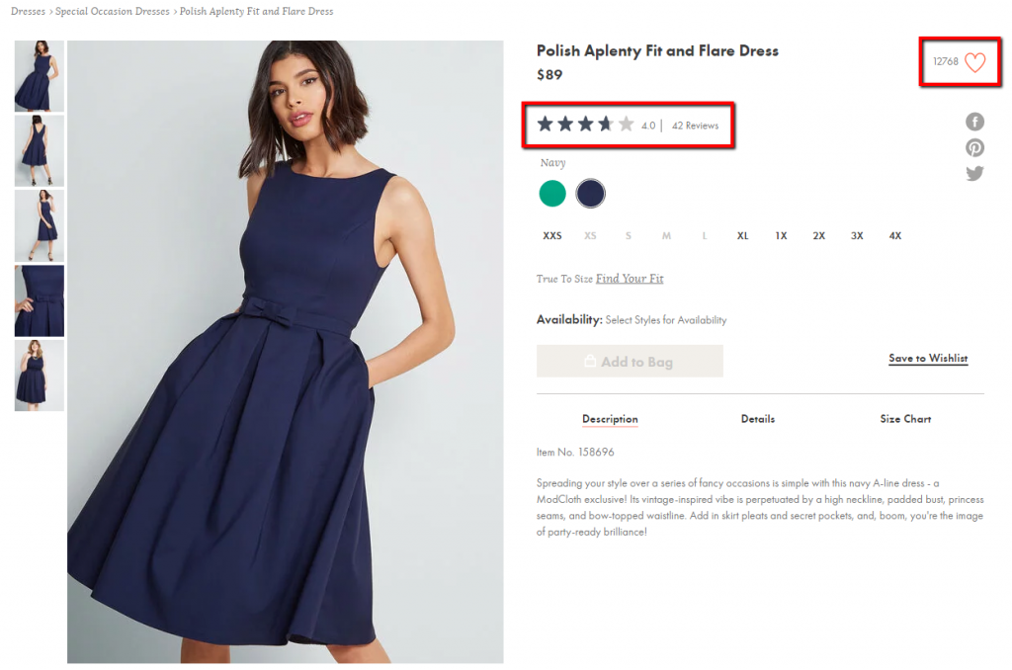

Interestingly, the more socially specific communications of this type are, the more effective they are. For example signs that say “8 out of 10 hotel guests who stay in this room choose to reuse their towels” are more effective than those that simply reference generic hotel guests.
This principle of consensus or social proof is a bit hard to use from a personal perspective in the world of work, but by managing you reputation and personal brand, it may just be possible to do so.
Update: Cialdini has since published a 7th principle: Unity.
This article is an amalgamation of 2 original works:
How to Use Cialdini’s 6 Principles of Persuasion to Boost Conversions
By: Marc Schenker Published: Jun 29, 2019 | Last updated: Mar 15, 2021
How to Use Cialdini's 6 Principles of Persuasion to Boost Conversions (cxl.com) accessed 1/25/2022
Cialdini’s 6 Principles of Persuasion: A Simple Summary
Summary by The World of Work Project
Cialdini's 6 Principles of Persuasion: A Simple Summary - The World of Work Project accessed 1/25/2022

